Ryerson University

Term Project

Winter 2020

Abdulrehman Khan (500968727)

Cps 125 - Section 081/082

Professor Dr. Joshua D Panar

April 13, 2020

**Objective:**

This term project aimed to extract various types of information from an initial data set of the “Daily Lake Average Surface Water Temperature From Great Lakes Surface Environmental Analysis maps” for 365 days and the year 2019. This included the surface water temperature in °C of the 6 great lakes in Canada which are: Lake Superior, Lake Huron, Lake Michigan, Lake Erie, Lake Ontario and, Lake Superior. The type of information extracted from the data set includes but is not limited to: yearly average temperature for the lakes, warmest and coldest lake, yearly summer average, yearly winter average, days the lakes are safe to swim in and days the lakes are dangerous to swim in. This can all be calculated by a C program through the use of 2D Arrays which will display the different averages. Through the use of C programming, we are rapidly and efficiently able to calculate all these things, whereas doing it manually would be much more time consuming and are likely to make errors that the computer would not.

**Part 1:**

**Code Display:**

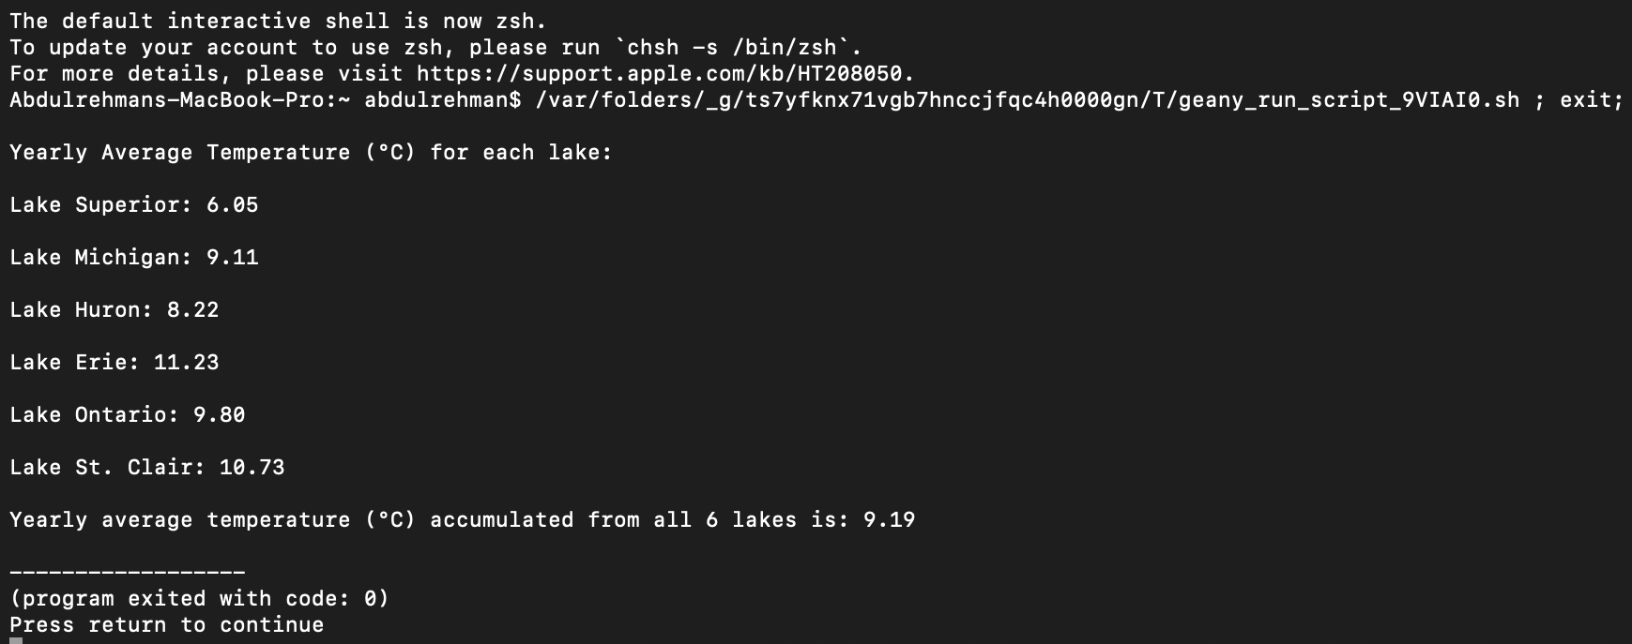

**Table 1: Yearly Average Temperature (°C) in 2019 for each lake**

| **Lake Name** | **Yearly Average Temperature (°C)** |
| --- | --- |
| Lake Superior | 6.05 |
| Lake Michigan | 9.11 |
| Lake Huron | 8.22 |
| Lake Erie | 11.23 |
| Lake Ontario | 9.80 |
| Lake St. Clair | 10.73 |

**Yearly Average Temperature (°C) in 2019 for all 6 lakes:** 9.19°C

**Figure 1: Yearly Average Temperature (°C) in 2019 for each lake**

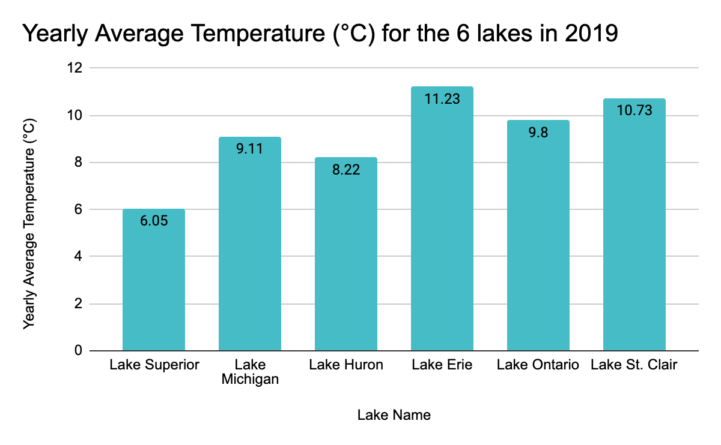

From the graph we can grasp, the temperatures were fairly similar throughout the years with the exception of Lake Superior which was slightly lower. Lake Michigan, Lake Erie, Lake Ontario and Lake St. Clair are all around 9-12°C whereas Lake Huron and, Lake Superior are on the lower side around 8°C and 6°C respectively.

**Part 2:**

**Code Display:**

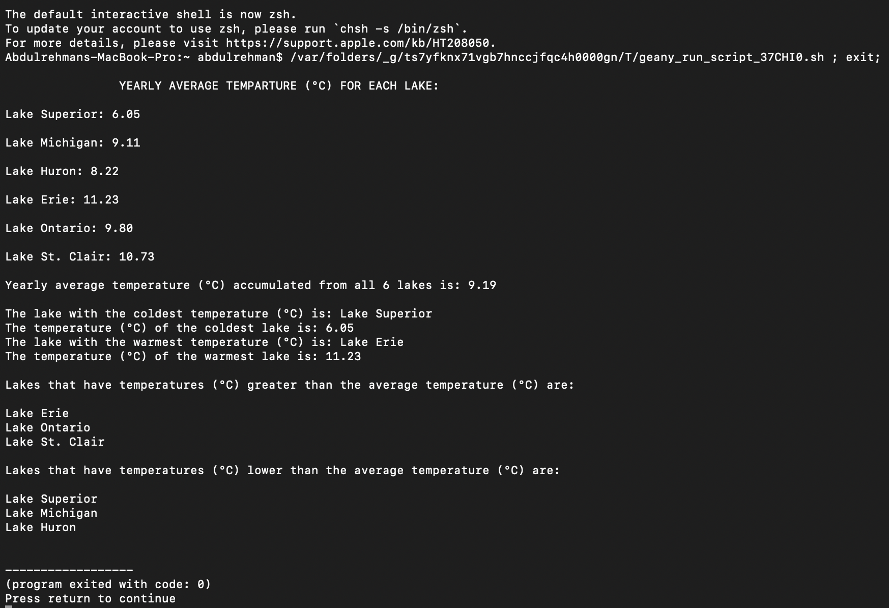

It can be seen from the code display that Lake Superior was the coldest lake with a temperature of 6.05°C which makes sense as even in graph 1 Lake Superior had the lowest temperature. Whereas the warmest lake was Lake Erie with a temperature of 11.23°C which also makes sense looking at graph 1 as that had the highest temperature. In conclusion Lake Erie, the warmest lake has a temperature 1.86 times as great as the coldest lake, Lake Superior.

**Table 2: Lakes Above Average temperature (°C) vs Lakes below Average temperature (°C) in 2019**

| **Lakes Above Average temperature (°C)** | **Lakes below Average temperature (°C)** |
| --- | --- |
| Lake Erie | Lake Superior |
| Lake Ontario | Lake Michigan |
| Lake St. Clair | Lake Huron |

**Part 3:**

**Code Display:**

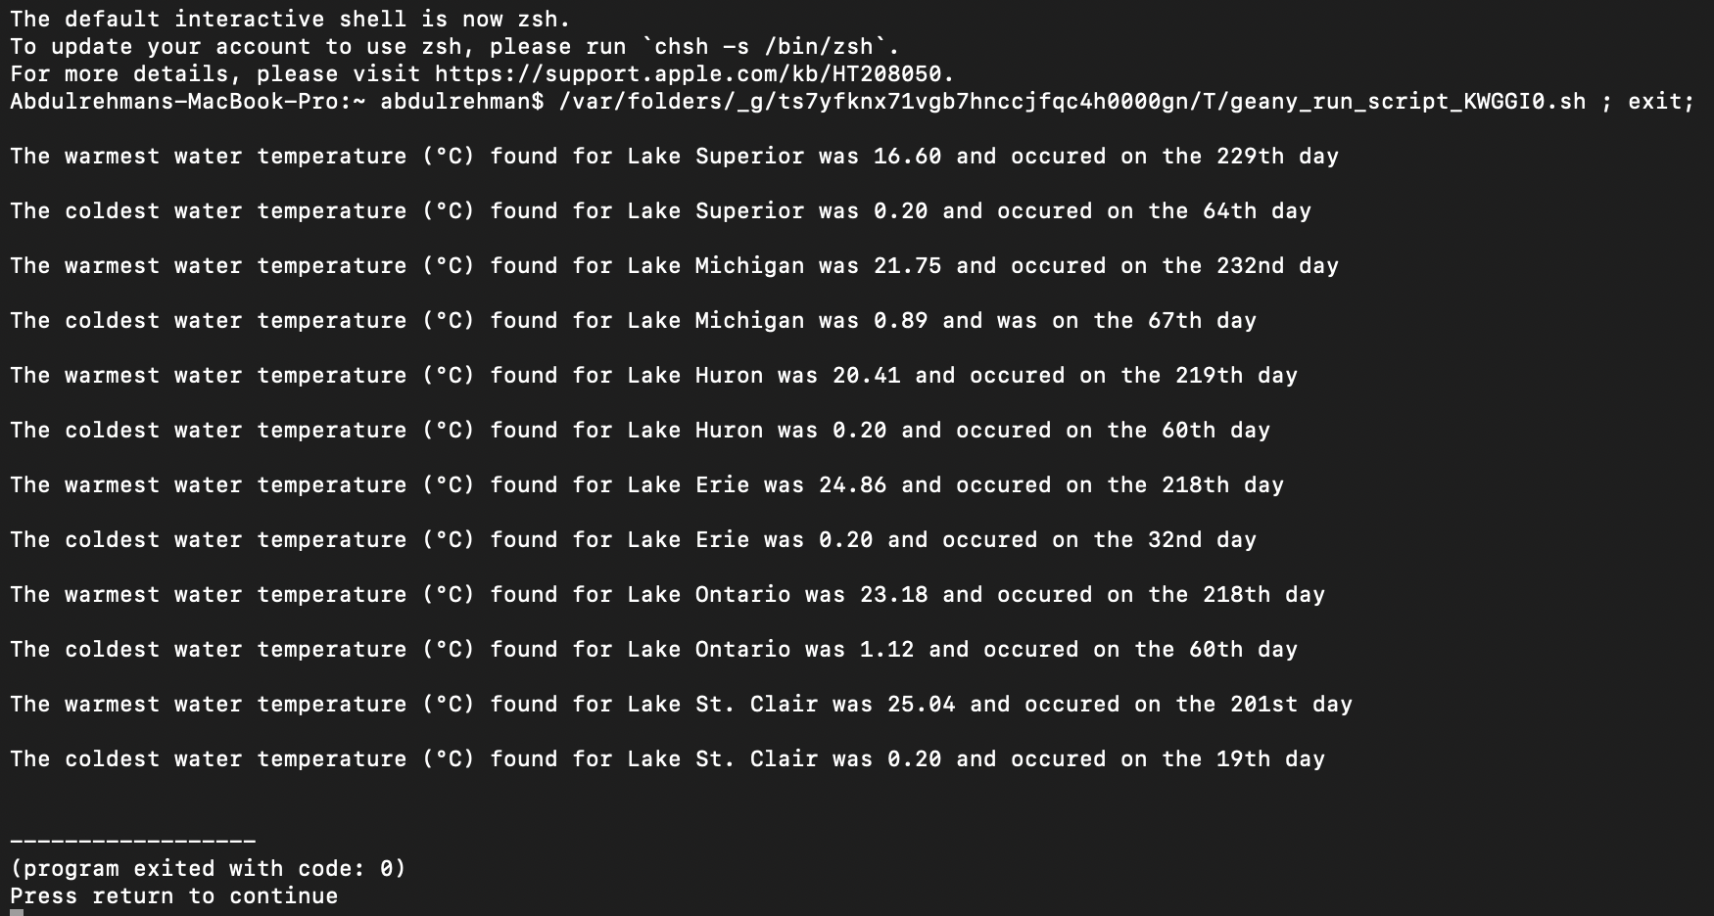

The code in coherence with the graph results down below. This also confirms that Lake St. Clair had the warmest temperature of 25.04°C. The coldest temperature was the same at 0.20°C between Lake Superior, Lake Huron, Lake Erie, and Lake St. Clair. The results display Lake St. Clair as the coldest lake, due to its value of 0.20 being checked last for being the coldest lake and therefore taking the place of the earlier lakes and being the last lake stored for the coldest day.

**Table 3: Yearly Warmest Temperature (°C) Vs. Yearly Coldest Temperature (°C) for each lake in 2019**

| **Lake Name** | **Yearly Warmest Temperature (°C)** | **Day of Warmest Temperature (°C)** | **Yearly Coldest Temperature (°C)** | **Day of Coldest Temperature (°C)** |
| --- | --- | --- | --- | --- |
| Lake Superior | 16.60 | 229th | 0.20 | 64th |
| Lake Michigan | 21.75 | 232nd | 0.89 | 67th |
| Lake Huron | 20.41 | 219th | 0.20 | 60th |
| Lake Erie | 24.86 | 218th | 0.20 | 32nd |
| Lake Ontario | 23.18 | 218th | 1.12 | 60th |
| Lake St. Clair | 25.04 | 201st | 0.20 | 19th |

**Figure 2:**

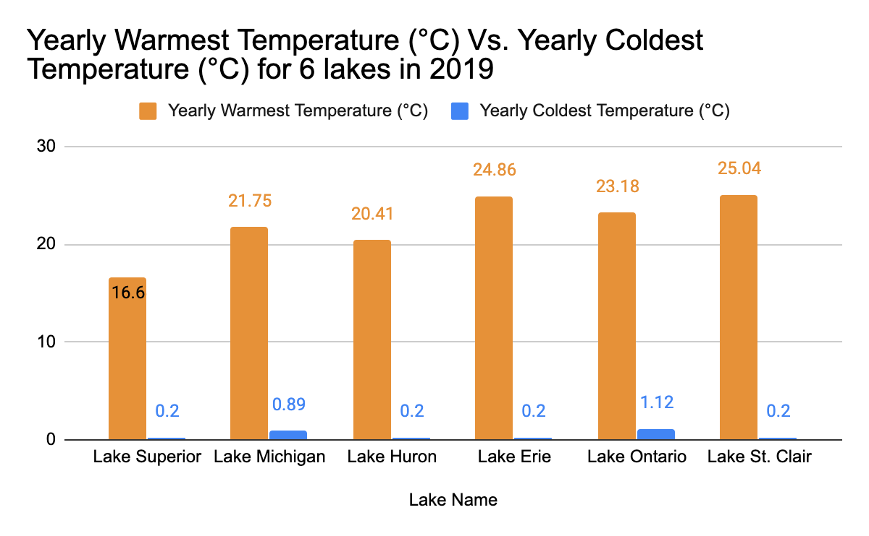

The graph displays both the yearly warmest and yearly coldest temperatures (°C) and it can be concluded that Lake St. Clair has the warmest temperature of 25.04°C and the coldest temperature of 0.20°C.

**Part 4:**

**Code Display:**

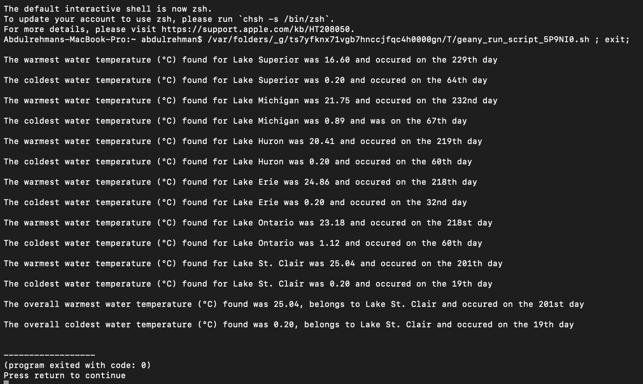

Similarly to the code in part 3, this part also shows the yearly warmest/coldest temperature for each lake. But in addition, it shows the overall warmest and coldest temperature calculated from all the yearly warmest/coldest temperatures which I have discussed above as well.

**Part 5:**

**Code Display:**

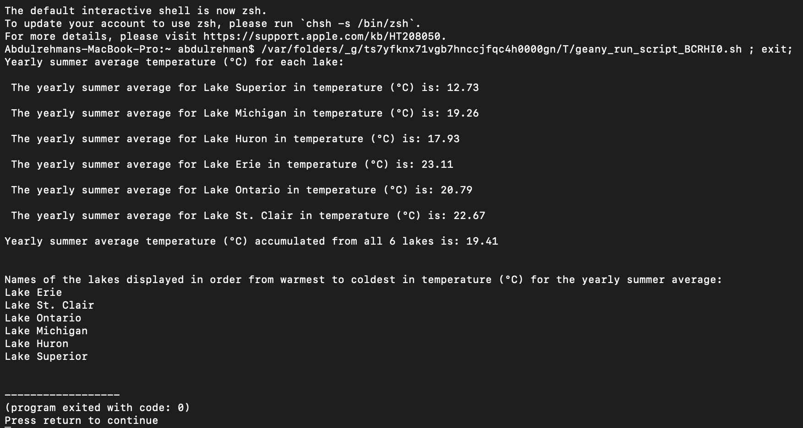

In this part, only the summer temperatures were taken from the data file (days 172- 265) and used in my for loop. From that, the yearly summer average temperature (°C) for all the lakes in 2019 was calculated.

**Table 4: Yearly Summer Average for each lake in 2019:**

| **Lake Name** | **Yearly Summer Average Temperature (°C)** |
| --- | --- |
| Lake Superior | 12.73 |
| Lake Michigan | 19.26 |
| Lake Huron | 17.93 |
| Lake Erie | 23.11 |
| Lake Ontario | 20.79 |
| Lake St. Clair | 22.67 |

**Yearly Summer Average Temperature (°C) in 2019 for all 6 lakes:** 19.41°C

**Figure 3:**

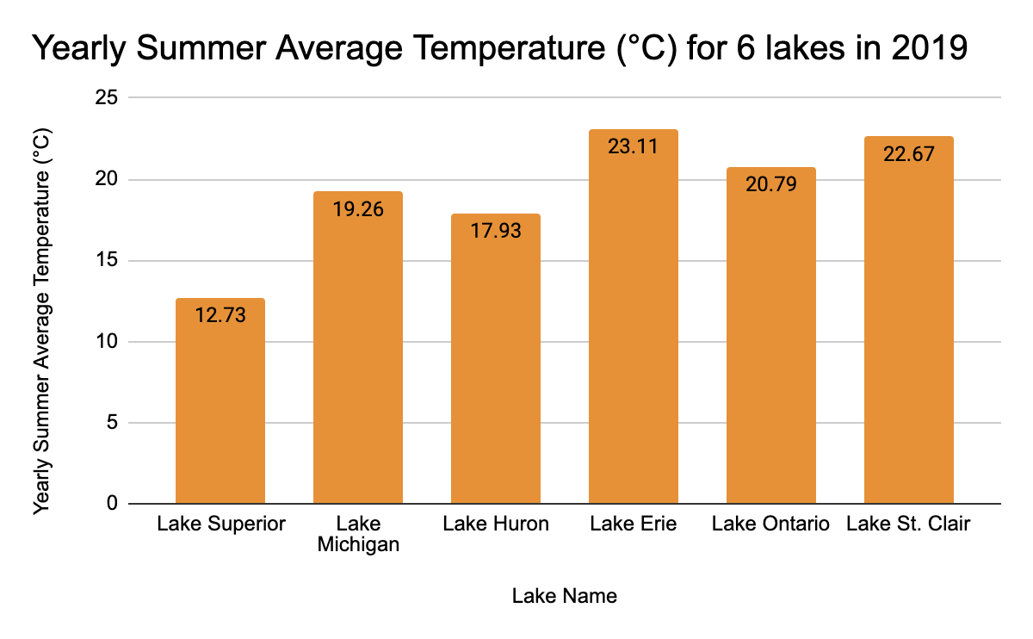

From the graph, we can gather that Lake Erie takes the spot for having the highest yearly summer average temperature (°C) in 2019. Following Lake Erie in descending order are Lake St. Clair, Lake Ontario, Lake Michigan, Lake Huron, and Lake Superior. In addition, the order from the warmest to coldest is indeed the same as the order found in step #2 for the 6 lakes in 2019. This can be confirmed by comparing both Graph 1 and Graph 3 together.

**Part 6:**

**Code Display:**

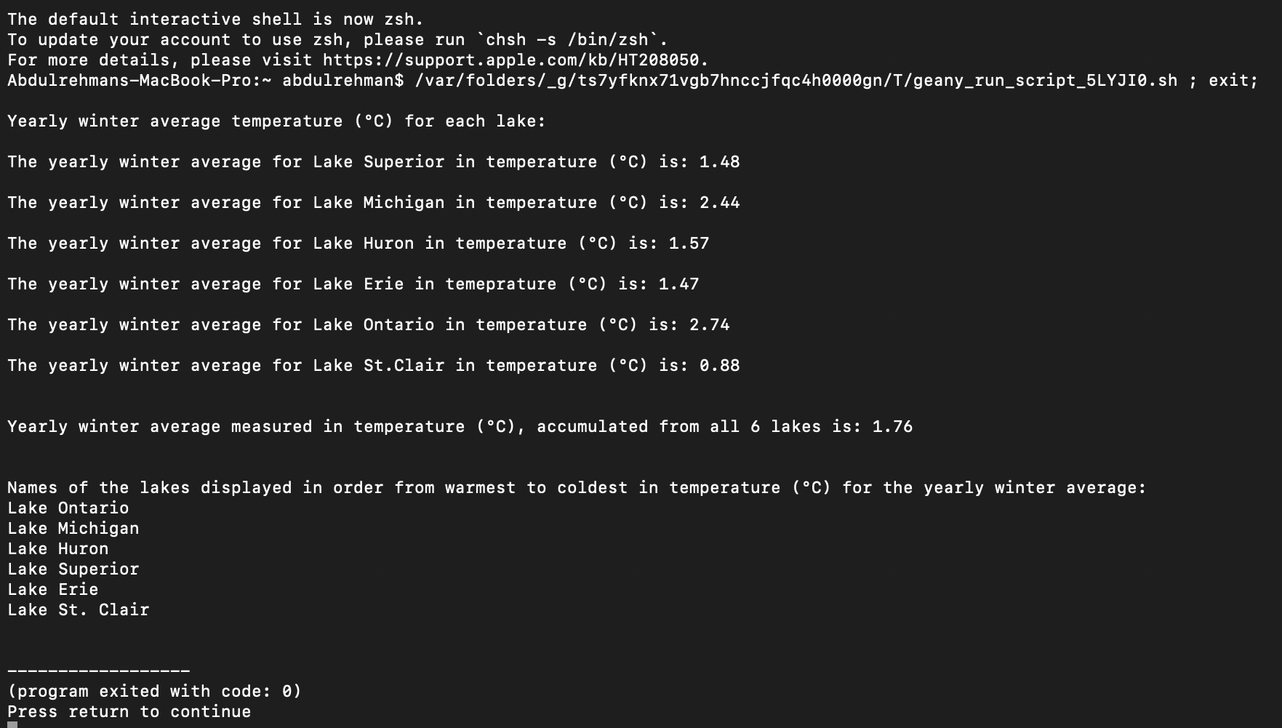

In this part, only the winter temperatures were taken from the data file (days 1-79 and days 355-365) and used in my for loop. From that, the yearly winter average temperature (°C) for all the lakes in 2019 was calculated.

**Table 5: Yearly Winter Average for each lake in 2019:**

| **Lake Name** | **Yearly Winter Average Temperature (°C)** |
| --- | --- |
| Lake Superior | 1.48 |
| Lake Michigan | 2.44 |
| Lake Huron | 1.57 |
| Lake Erie | 1.47 |
| Lake Ontario | 2.74 |
| Lake St. Clair | 0.88 |

**Yearly Winter Average Temperature (°C) in 2019 for all 6 lakes:** 1.76°C

**Figure 4:**

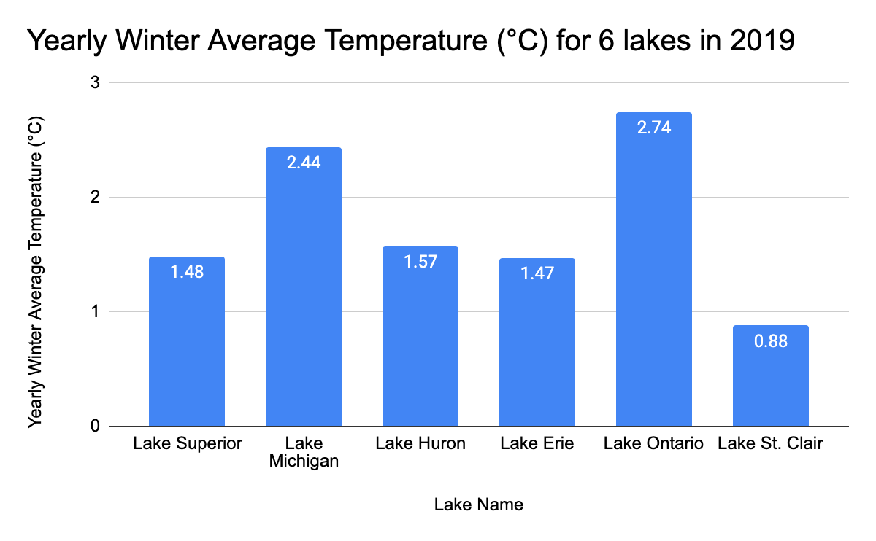

From the graph, we can gather that Lake Ontario takes the spot for having the highest yearly winter average temperature (°C) in 2019. Following Lake Ontario in descending order are Lake Michigan, Lake Huron, Lake Superior, Lake Erie, and Lake St. Clair. Also, the order from the warmest to coldest is not the same as the order found in step #2 for the 6 lakes in 2019. This can be confirmed by comparing Graph 1 and Graph 4 together.

**Part 7:**

**Code Display:**

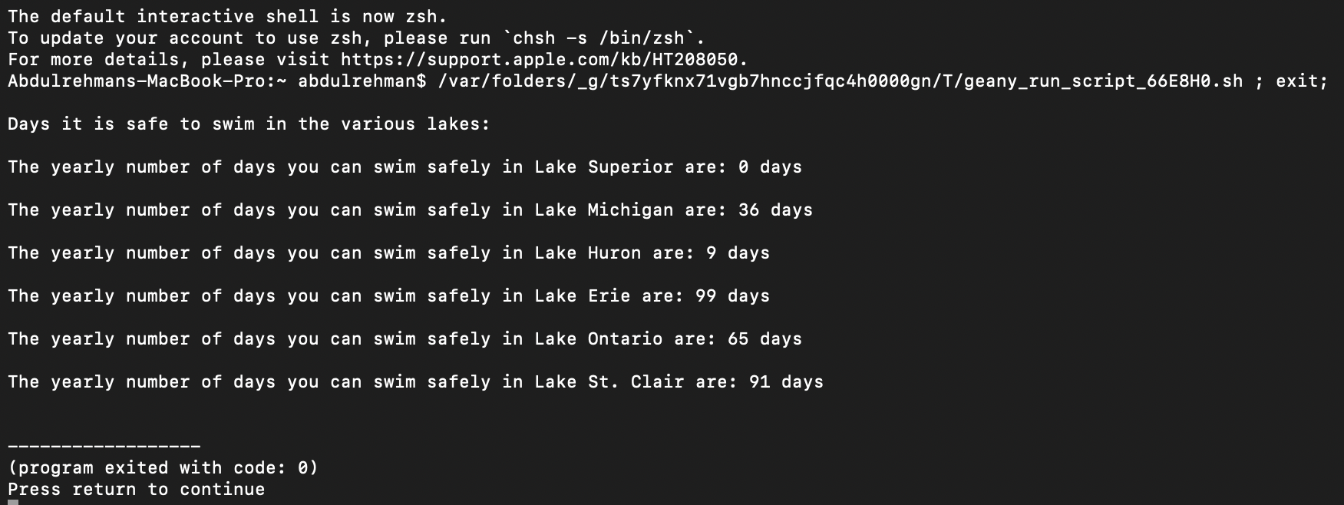

**Table 6: Number of days the lakes were safe to swim in (Temperature > 20°C) in 2019**

| **Lake Name** | **Days it was Safe to Swim in each of the lakes** |
| --- | --- |
| Lake Superior | 0 |
| Lake Michigan | 36 |
| Lake Huron | 9 |
| Lake Erie | 99 |
| Lake Ontario | 65 |
| Lake St. Clair | 91 |

**Figure 5:**

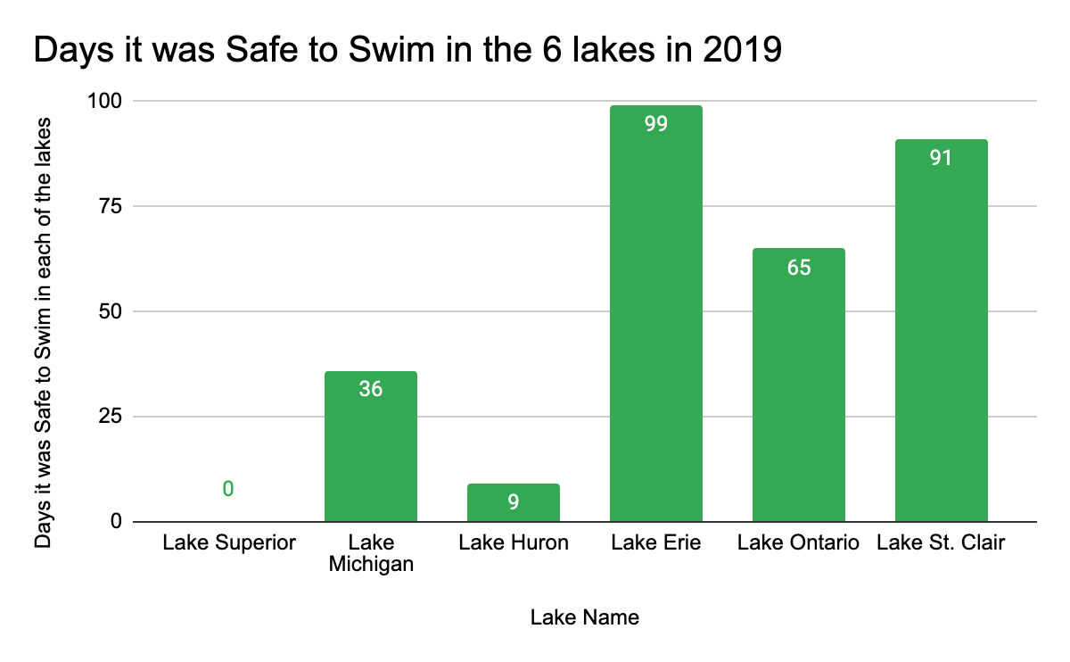

From the graph, it is apparent that Lake Erie was the safest lake to swim in with 99 days being declared safe to swim in 2019. Lake Erie being followed in descending order by Lake St. Clair, Lake Ontario, Lake Michigan, Lake Huron and, Lake Superior.

**Part 8:**

**Code Display:**

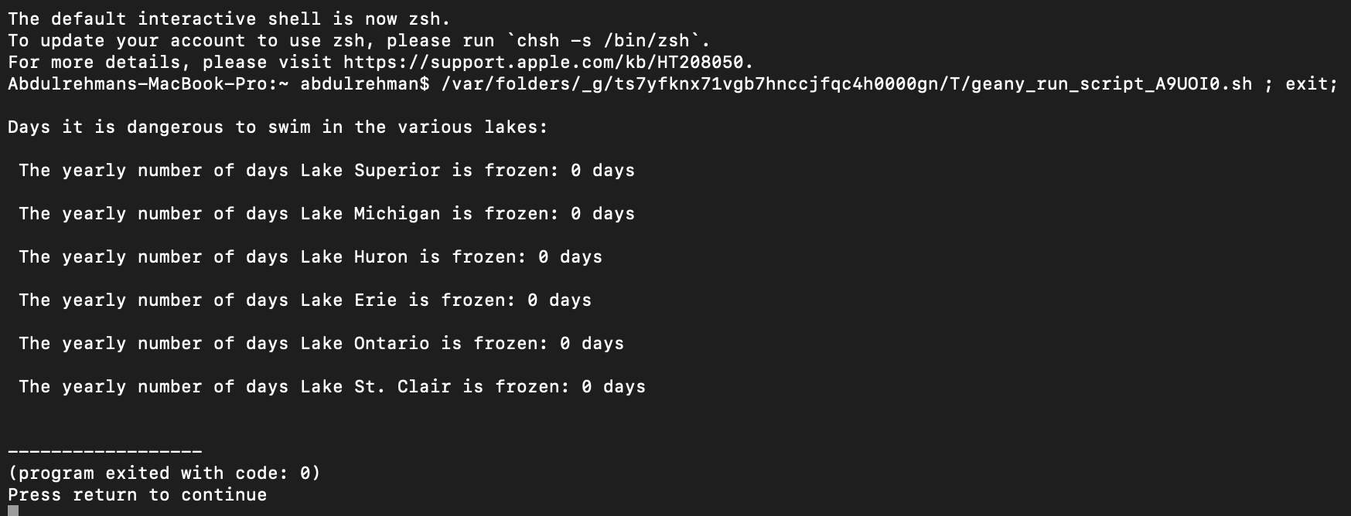

**Table 7: Number of days the lakes were frozen (Temperature < 0°C) in 2019**

| **Lake Name** | **Days each of the lakes were Frozen** |
| --- | --- |
| Lake Superior | 0 |
| Lake Michigan | 0 |
| Lake Huron | 0 |
| Lake Erie | 0 |
| Lake Ontario | 0 |
| Lake St. Clair | 0 |

**Figure 6:**

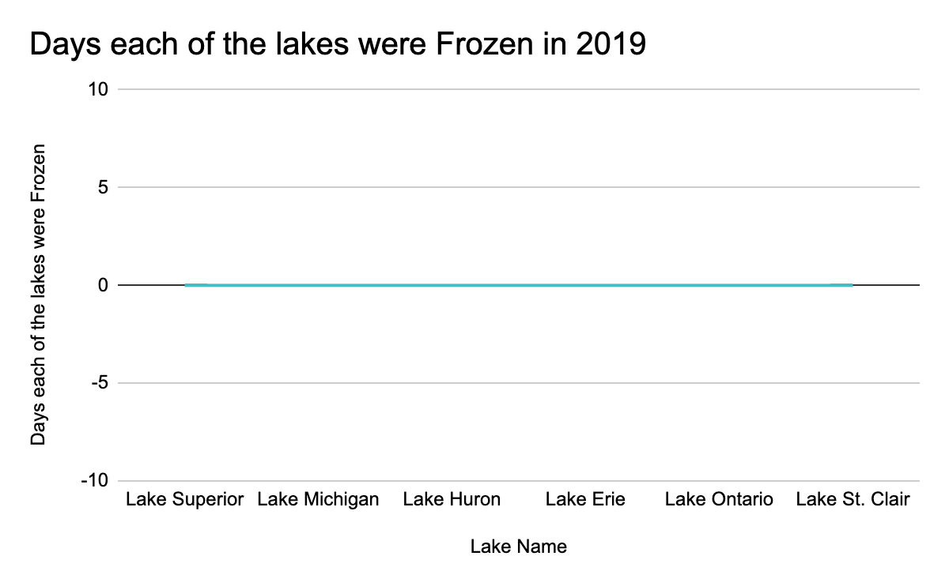

None of the lakes were frozen in 2019.

**Part 9:**

**Code Display:**

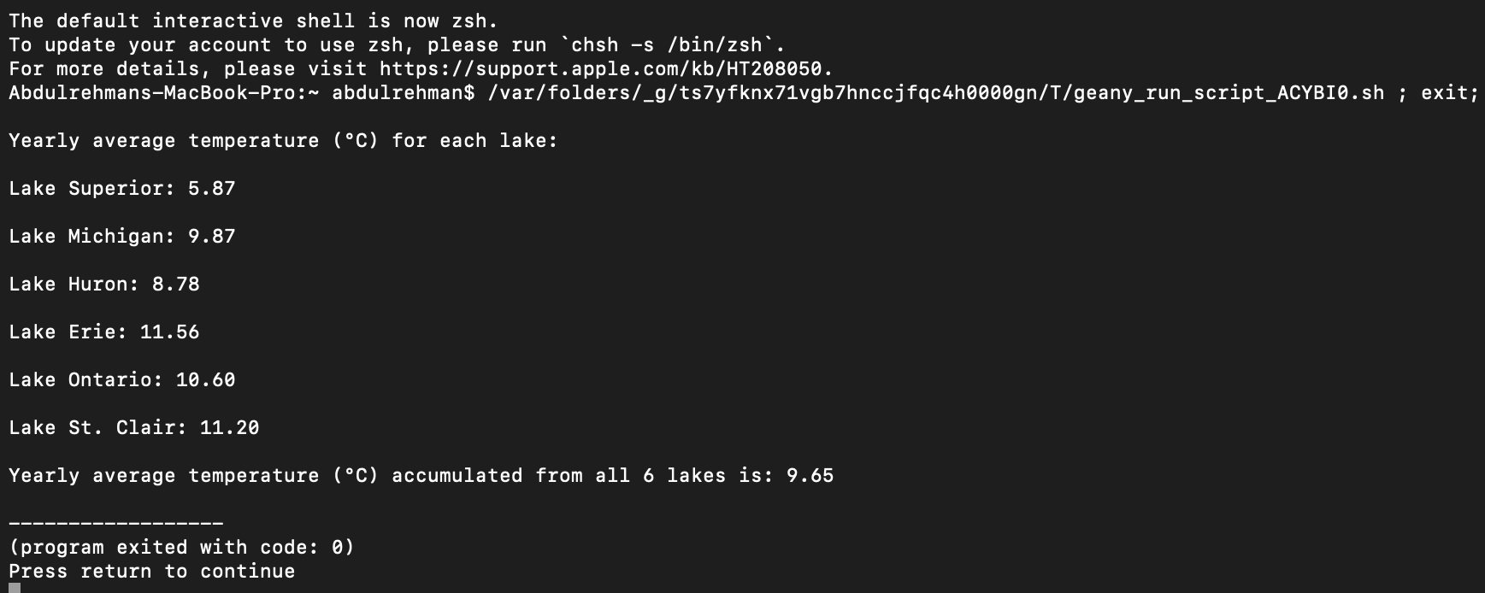

**Table 8: Yearly Average Temperature (°C) in 2018 for each lake**

| **Lake Name** | **Yearly Average Temperature (°C)** |
| --- | --- |
| Lake Superior | 5.87 |
| Lake Michigan | 9.87 |
| Lake Huron | 8.78 |
| Lake Erie | 11.56 |
| Lake Ontario | 10.60 |
| Lake St. Clair | 11.20 |

**Yearly Average Temperature (°C) in 2018 for all 6 lakes:** 9.65°C

**Figure 7:**

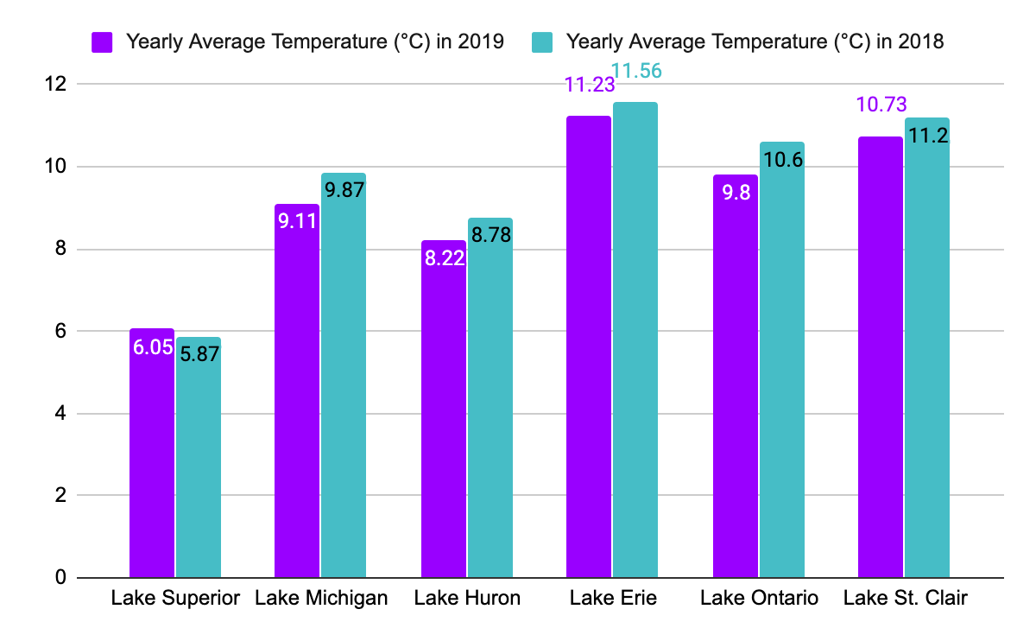

This graph is showing the comparison of the yearly average temperature (°C) in 2019 vs the yearly average temperature (°C) in 2018. We can summarize from the graph that overall, the yearly average temperature (°C) in 2018 was greater than the yearly average temperature (°C) in 2019, with the only exception being Lake Superior.

**Conclusion:**

In closing, working on this term project was a very lengthy yet memorable experience, to say the least. This term project gave me insight into how real-life coding tasks could feel like, being that this was the first big coding project I have ever had the opportunity to work on. Additionally, it helped not only my understanding of 2D arrays but also helped develop my skills in different aspects of C programming, including the use of files and string functions. Furthermore, this term project increased my debugging and troubleshooting skills as there were a lot of times I found myself stuck and not truly understanding where I went wrong. It was through this project that I learned to look at things very meticulously and to tell myself to take a break when frustrated! If I was to do this project again, I would try to decrease the amount of lines in my code. I would approach this through the use of function calls and the use of structures to replace my if/else statements. This would increase the efficiency of the code and in turn decrease the amount of lines in the code at the same time, perhaps making the code more visually appealing than it already is. Talking about visual appearance, the use of pseudocode would also increase the visual appearance of the code.

**Appendix:**

**Part 1:**

#include <stdio.h>

#include <math.h>

#include <stdlib.h>

#include <string.h>

/* ELEMENT/PART 1 */

int

main (void)

{

int a;

int b;

float sup;

float mich;

float huron;

float erie;

float ont;

float stclair;

float avgsup;

float avgmich;

float avghuron;

float avgerie;

float avgont;

float avgstclair;

float totalavg;

float A1[365][8];

/* Reading and storing data */

FILE *in;

in=fopen("avgtemps2019.txt", "r");

if (in==NULL) exit(1);

for (a=0; a<365; a++){

for (b=0; b<8; b++){

fscanf(in,"%f", &A1[a][b]);}}

fclose(in);

printf("\nYearly Average Temperature (°C) for each lake:\n");

/* Calculates the yearly average temperature (°C) for lake Superior */

sup=0;

for (a=0; a<365; a++){

sup=sup+A1[a][2];}

avgsup=sup/365;

printf("\nLake Superior: %.2f\n", avgsup);

/* Calculates the yearly average temperature (°C) for lake Michigan */

mich=0;

for (a=0; a<365; a++){

mich=mich+A1[a][3];}

avgmich=mich/365;

printf("\nLake Michigan: %.2f\n", avgmich);

/* Calculates the yearly average temperature (°C) for lake Huron */

huron=0;

for (a=0; a<365; a++){

huron=huron+A1[a][4];}

avghuron=huron/365;

printf("\nLake Huron: %.2f\n", avghuron);

/* Calculates the yearly average temperature (°C) for lake Erie */

erie=0;

for (a=0; a<365; a++){

erie=erie+A1[a][5];}

avgerie=erie/365;

printf("\nLake Erie: %.2f\n", avgerie);

/* Calculates the yearly average temperature (°C) for lake Ontario */

ont=0;

for (a=0; a<365; a++){

ont=ont+A1[a][6];}

avgont=ont/365;

printf("\nLake Ontario: %.2f\n", avgont);

/* Calculates the yearly average temperature (°C) for lake St. Clair */

stclair=0;

for (a=0; a<365; a++){

stclair=stclair+A1[a][7];}

avgstclair=stclair/365;

printf("\nLake St. Clair: %.2f\n", avgstclair);

/* Calculates the yearly average of all the lakes put together */

totalavg= (avgsup+avgmich+avghuron+avgerie+avgont+avgstclair)/6;

printf("\nYearly average temperature (°C) accumulated from all 6 lakes is: %.2f", totalavg);

return (0);}

**Part 2:**

#include <stdio.h>

#include <math.h>

#include <stdlib.h>

#include <string.h>

/* ELEMENT/PART 2 */

int

main (void)

{

int a;

int b;

float sup;

float mich;

float huron;

float erie;

float ont;

float stclair;

float avgsup;

float avgmich;

float avghuron;

float avgerie;

float avgont;

float avgstclair;

float totalavg;

float A1[365][8];

/* Reading and storing data */

FILE *in;

in=fopen("avgtemps2019.txt", "r");

if (in==NULL) exit(1);

for (a=0; a<365; a++){

for (b=0; b<8; b++){

fscanf(in,"%f", &A1[a][b]);}}

fclose(in);

printf("\nYearly Average Temperature (°C) for each lake:\n");

/* Calculates the yearly average temperature (°C) for lake Superior */

sup=0;

for (a=0; a<365; a++){

sup=sup+A1[a][2];}

avgsup=sup/365;

printf("\nLake Superior: %.2f\n", avgsup);

/* Calculates the yearly average temperature (°C) for lake Michigan */

mich=0;

for (a=0; a<365; a++){

mich=mich+A1[a][3];}

avgmich=mich/365;

printf("\nLake Michigan: %.2f\n", avgmich);

/* Calculates the yearly average temperature (°C) for lake Huron */

huron=0;

for (a=0; a<365; a++){

huron=huron+A1[a][4];}

avghuron=huron/365;

printf("\nLake Huron: %.2f\n", avghuron);

/* Calculates the yearly average temperature (°C) for lake Erie */

erie=0;

for (a=0; a<365; a++){

erie=erie+A1[a][5];}

avgerie=erie/365;

printf("\nLake Erie: %.2f\n", avgerie);

/* Calculates the yearly average temperature (°C) for lake Ontario */

ont=0;

for (a=0; a<365; a++){

ont=ont+A1[a][6];}

avgont=ont/365;

printf("\nLake Ontario: %.2f\n", avgont);

/* Calculates the yearly average temperature (°C) for lake St. Clair */

stclair=0;

for (a=0; a<365; a++){

stclair=stclair+A1[a][7];}

avgstclair=stclair/365;

printf("\nLake St. Clair: %.2f\n", avgstclair);

/* Calculates the yearly average temperature (°C) of all the lakes together */

totalavg= (avgsup+avgmich+avghuron+avgerie+avgont+avgstclair)/6;

printf("\nYearly average temperature (°C) accumulated from all 6 lakes is: %.2f\n", totalavg);

/* Calculates the warmest and coldest lakes, depending on the yearly average temperature (°C) */

float warmest;

float coldest;

float warm[6]= {avgsup,avgmich,avghuron,avgerie,avgont,avgstclair};

float cold[6]= {avgsup,avgmich,avghuron,avgerie,avgont,avgstclair};

warmest= warm[0];

coldest= cold[0];

for (a=1; a<6; a++){

if (warmest< warm[a]) warmest= warm[a];

if (coldest> cold[a]) coldest= cold[a];}

char* identity[6];

identity[0]= "Lake Superior";

identity[1]= "Lake Michigan";

identity[2]= "Lake Huron";

identity[3]= "Lake Erie";

identity[4]= "Lake Ontario";

identity[5]= "Lake St. Clair";

for (int e=0;e<6;e++){

if(warmest==warm[e]){

printf("\nThe lake with the warmest temperature (°C) is: ");

puts(identity[e]);

printf("The temperature (°C) of the warmest lake is: %.2f", warmest);}

if (coldest==cold[e]){

printf("\nThe lake with the coldest temperature (°C) is: ");

puts(identity[e]);

printf("The temperature (°C) of the coldest lake is: %.2f", coldest);}}

/* Calculates which lakes have temperatures (°C) above and which lakes have temperatures (°C) below the average temperature (°C) */

printf("\n\nLakes that have temperatures (°C) greater than the average temperature (°C) are: \n\n");

for (int d=0; d<6; d++){

if (warm[d]>totalavg){

puts(identity[d]);}}

printf("\nLakes that have temperatures (°C) lower than the average temperature (°C) are: \n\n");

for (int b=0;b<6;b++){

if (warm[b]<totalavg){

puts(identity[b]);}}

return(0);}

**Part 3:**

#include <stdio.h>

#include <math.h>

#include <stdlib.h>

#include <string.h>

/* ELEMENT/PART 3 */

int

main (void)

{

int a;

int b;

float A1[365][8];

float supwarmest;

float supwarmestday;

float supcoldest;

float supcoldestday;

float michwarmest;

float michwarmestday;

float michcoldest;

float michcoldestday;

float huronwarmest;

float huronwarmestday;

float huroncoldest;

float huroncoldestday;

float eriewarmest;

float eriewarmestday;

float eriecoldest;

float eriecoldestday;

float ontwarmest;

float ontwarmestday;

float ontcoldest;

float ontcoldestday;

float stclairwarmest;

float stclairwarmestday;

float stclaircoldest;

float stclaircoldestday;

/* Reading and storing data */

FILE *in;

in=fopen("avgtemps2019.txt", "r");

if (in==NULL) exit(1);

for (a=0; a<365; a++){

for (b=0; b<8; b++){

fscanf(in,"%f", &A1[a][b]);}}

fclose(in);

/* Calculates warmest and coldest day for Lake Superior */

supwarmest=A1[0][2];

supcoldest=A1[0][2];

supwarmestday=A1[0][1];

supcoldestday=A1[0][1];

for (a=1;a<365;a++){

if (supwarmest<A1[a][2])(supwarmest=A1[a][2]) && (supwarmestday=A1[a][1]);

if (supcoldest>A1[a][2])(supcoldest=A1[a][2]) && (supcoldestday=A1[a][1]);}

printf("\nThe warmest water temperature (°C) found for Lake Superior was %.2f and occured on the %0.0fth day\n", supwarmest, supwarmestday);

printf("\nThe coldest water temperature (°C) found for Lake Superior was %.2f and occured on the %0.0fth day\n", supcoldest, supcoldestday);

/* Calculates warmest and coldest day for Lake Michigan */

michwarmest=A1[0][3];

michcoldest=A1[0][3];

michwarmestday=A1[0][1];

michcoldestday=A1[0][1];

for (a=1;a<365;a++){

if (michwarmest<A1[a][3])(michwarmest=A1[a][3]) && (michwarmestday=A1[a][1]);

if (michcoldest>A1[a][3])(michcoldest=A1[a][3]) && (michcoldestday=A1[a][1]);}

printf("\nThe warmest water temperature (°C) found for Lake Michigan was %.2f and occured on the %0.0fnd day\n", michwarmest, michwarmestday);

printf("\nThe coldest water temperature (°C) found for Lake Michigan was %.2f and was on the %0.0fth day\n", michcoldest, michcoldestday);

/* Calculates warmest and coldest day for Lake Huron */

huronwarmest=A1[0][4];

huroncoldest=A1[0][4];

huronwarmestday=A1[0][1];

huroncoldestday=A1[0][1];

for (a=1;a<365;a++){

if (huronwarmest<A1[a][4])(huronwarmest=A1[a][4]) && (huronwarmestday=A1[a][1]);

if (huroncoldest>A1[a][4])(huroncoldest=A1[a][4]) && (huroncoldestday=A1[a][1]);}

printf("\nThe warmest water temperature (°C) found for Lake Huron was %.2f and occured on the %0.0fth day\n", huronwarmest, huronwarmestday);

printf("\nThe coldest water temperature (°C) found for Lake Huron was %.2f and occured on the %0.0fth day\n", huroncoldest, huroncoldestday);

/* Calculates warmest and coldest day for Lake Erie */

eriewarmest=A1[0][5];

eriecoldest=A1[0][5];

eriewarmestday=A1[0][1];

eriecoldestday=A1[0][1];

for (a=1;a<365;a++){

if (eriewarmest<A1[a][5])(eriewarmest=A1[a][5]) && (eriewarmestday=A1[a][1]);

if (eriecoldest>A1[a][5])(eriecoldest=A1[a][5]) && (eriecoldestday=A1[a][1]);}

printf("\nThe warmest water temperature (°C) found for Lake Erie was %.2f and occured on the %0.0fth day\n", eriewarmest, eriewarmestday);

printf("\nThe coldest water temperature (°C) found for Lake Erie was %.2f and occured on the %0.0fnd day\n", eriecoldest, eriecoldestday);

/* Calculates warmest and coldest day for Lake Ontario */

ontwarmest=A1[0][6];

ontcoldest=A1[0][6];

ontwarmestday=A1[0][1];

ontcoldestday=A1[0][1];

for (a=1;a<365;a++){

if (ontwarmest<A1[a][6])(ontwarmest=A1[a][6]) && (ontwarmestday=A1[a][1]);

if (ontcoldest>A1[a][6])(ontcoldest=A1[a][6]) && (ontcoldestday=A1[a][1]);}

printf("\nThe warmest water temperature (°C) found for Lake Ontario was %.2f and occured on the %0.0lfth day\n", ontwarmest, ontwarmestday);

printf("\nThe coldest water temperature (°C) found for Lake Ontario was %.2f and occured on the %0.0lfth day\n", ontcoldest, ontcoldestday);

/* Calculates warmest and coldest day for Lake St. Clair */

stclairwarmest=A1[0][7];

stclaircoldest=A1[0][7];

stclairwarmestday=A1[0][1];

stclaircoldestday=A1[0][1];

for (a=1;a<365;a++){

if (stclairwarmest<A1[a][7])(stclairwarmest=A1[a][7]) && (stclairwarmestday=A1[a][1]);

if (stclaircoldest>A1[a][7])(stclaircoldest=A1[a][7]) && (stclaircoldestday=A1[a][1]);}

printf("\nThe warmest water temperature (°C) found for Lake St. Clair was %.2f and occured on the %0.0fst day\n", stclairwarmest, stclairwarmestday);

printf("\nThe coldest water temperature (°C) found for Lake St. Clair was %.2f and occured on the %0.0fth day\n", stclaircoldest, stclaircoldestday);

return(0);}

**Part 4:**

#include <stdio.h>

#include <math.h>

#include <stdlib.h>

#include <string.h>

/* ELEMENT/PART 4 */

int

main (void)

{

int a;

int b;

float A1[365][8];

float supwarmest;

float supwarmestday;

float supcoldest;

float supcoldestday;

float michwarmest;

float michwarmestday;

float michcoldest;

float michcoldestday;

float huronwarmest;

float huronwarmestday;

float huroncoldest;

float huroncoldestday;

float eriewarmest;

float eriewarmestday;

float eriecoldest;

float eriecoldestday;

float ontwarmest;

float ontwarmestday;

float ontcoldest;

float ontcoldestday;

float stclairwarmest;

float stclairwarmestday;

float stclaircoldest;

float stclaircoldestday;

/* Reading and storing data */

FILE *in;

in=fopen("avgtemps2019.txt", "r");

if (in==NULL) exit(1);

for (a=0; a<365; a++){

for (b=0; b<8; b++){

fscanf(in,"%f", &A1[a][b]);}}

fclose(in);

/* Calculates warmest and coldest day for Lake Superior */

supwarmest=A1[0][2];

supcoldest=A1[0][2];

supwarmestday=A1[0][1];

supcoldestday=A1[0][1];

for (a=1;a<365;a++){

if (supwarmest<A1[a][2])(supwarmest=A1[a][2]) && (supwarmestday=A1[a][1]);

if (supcoldest>A1[a][2])(supcoldest=A1[a][2]) && (supcoldestday=A1[a][1]);}

printf("\nThe warmest water temperature (°C) found for Lake Superior was %.2f and occured on the %0.0fth day\n", supwarmest, supwarmestday);

printf("\nThe coldest water temperature (°C) found for Lake Superior was %.2f and occured on the %0.0fth day\n", supcoldest, supcoldestday);

/* Calculates warmest and coldest day for Lake Michigan */

michwarmest=A1[0][3];

michcoldest=A1[0][3];

michwarmestday=A1[0][1];

michcoldestday=A1[0][1];

for (a=1;a<365;a++){

if (michwarmest<A1[a][3])(michwarmest=A1[a][3]) && (michwarmestday=A1[a][1]);

if (michcoldest>A1[a][3])(michcoldest=A1[a][3]) && (michcoldestday=A1[a][1]);}

printf("\nThe warmest water temperature (°C) found for Lake Michigan was %.2f and occured on the %0.0fnd day\n", michwarmest, michwarmestday);

printf("\nThe coldest water temperature (°C) found for Lake Michigan was %.2f and was on the %0.0fth day\n", michcoldest, michcoldestday);

/* Calculates warmest and coldest day for Lake Huron */

huronwarmest=A1[0][4];

huroncoldest=A1[0][4];

huronwarmestday=A1[0][1];

huroncoldestday=A1[0][1];

for (a=1;a<365;a++){

if (huronwarmest<A1[a][4])(huronwarmest=A1[a][4]) && (huronwarmestday=A1[a][1]);

if (huroncoldest>A1[a][4])(huroncoldest=A1[a][4]) && (huroncoldestday=A1[a][1]);}

printf("\nThe warmest water temperature (°C) found for Lake Huron was %.2f and occured on the %0.0fth day\n", huronwarmest, huronwarmestday);

printf("\nThe coldest water temperature (°C) found for Lake Huron was %.2f and occured on the %0.0fth day\n", huroncoldest, huroncoldestday);

/* Calculates warmest and coldest day for Lake Erie */

eriewarmest=A1[0][5];

eriecoldest=A1[0][5];

eriewarmestday=A1[0][1];

eriecoldestday=A1[0][1];

for (a=1;a<365;a++){

if (eriewarmest<A1[a][5])(eriewarmest=A1[a][5]) && (eriewarmestday=A1[a][1]);

if (eriecoldest>A1[a][5])(eriecoldest=A1[a][5]) && (eriecoldestday=A1[a][1]);}

printf("\nThe warmest water temperature (°C) found for Lake Erie was %.2f and occured on the %0.0fth day\n", eriewarmest, eriewarmestday);

printf("\nThe coldest water temperature (°C) found for Lake Erie was %.2f and occured on the %0.0fnd day\n", eriecoldest, eriecoldestday);

/* Calculates warmest and coldest day for Lake Ontario */

ontwarmest=A1[0][6];

ontcoldest=A1[0][6];

ontwarmestday=A1[0][1];

ontcoldestday=A1[0][1];

for (a=1;a<365;a++){

if (ontwarmest<A1[a][6])(ontwarmest=A1[a][6]) && (ontwarmestday=A1[a][1]);

if (ontcoldest>A1[a][6])(ontcoldest=A1[a][6]) && (ontcoldestday=A1[a][1]);}

printf("\nThe warmest water temperature (°C) found for Lake Ontario was %.2f and occured on the %0.0fth day\n", ontwarmest, ontwarmestday);

printf("\nThe coldest water temperature (°C) found for Lake Ontario was %.2f and occured on the %0.0fth day\n", ontcoldest, ontcoldestday);

/* Calculates warmest and coldest day for Lake St. Clair */

stclairwarmest=A1[0][7];

stclaircoldest=A1[0][7];

stclairwarmestday=A1[0][1];

stclaircoldestday=A1[0][1];

for (a=1;a<365;a++){

if (stclairwarmest<A1[a][7])(stclairwarmest=A1[a][7]) && (stclairwarmestday=A1[a][1]);

if (stclaircoldest>A1[a][7])(stclaircoldest=A1[a][7]) && (stclaircoldestday=A1[a][1]);}

printf("\nThe warmest water temperature (°C) found for Lake St. Clair was %.2f and occured on the %0.0fst day\n", stclairwarmest, stclairwarmestday);

printf("\nThe coldest water temperature (°C) found for Lake St. Clair was %.2f and occured on the %0.0fth day\n", stclaircoldest, stclaircoldestday);

/* Calculates the overall warmest/coldest water temperature */

float warmest;

float coldest;

float warm[6] = {supwarmest,michwarmest,huronwarmest,eriewarmest,ontwarmest,stclairwarmest};

float cold[6] = {supcoldest,michcoldest,huroncoldest,eriecoldest,ontcoldest,stclaircoldest};

warmest= warm[0];

coldest= cold[0];

for (a=1; a<6; a++){

if (warmest< warm[a]) warmest= warm[a];

if (coldest> cold[a]) coldest= cold[a];}

printf("\nThe overall warmest water temperature (°C) found was %.2f, belongs to Lake St. Clair and occured on the 201st day \n", warmest);

printf("\nThe overall coldest water temperature (°C) found was %.2f, belongs to Lake St. Clair and occured on the 19th day\n", coldest);

return(0);}

**Part 5:**

#include <stdio.h>

#include <math.h>

#include <stdlib.h>

#include <string.h>

/* ELEMENT/PART 5 */

int

main (void)

{

int a;

int b;

float sup;

float mich;

float huron;

float erie;

float ont;

float stclair;

float avgsup;

float avgmich;

float avghuron;

float avgerie;

float avgont;

float avgstclair;

float totalavg;

float A1[365][8];

/* Reading and storing data */

FILE *in;

in=fopen("avgtemps2019.txt", "r");

if (in==NULL) exit(1);

for (a=0; a<365; a++){

for (b=0; b<8; b++){

fscanf(in,"%f", &A1[a][b]);}}

fclose(in);

printf("Yearly summer average temperature (°C) for each lake:\n");

/* Calculates the yearly summer average in temperature (°C) for Lake Superior */

sup=0;

for (a=171; a<265; a++){

sup=sup+A1[a][2];}

avgsup=sup/93;

printf("\n The yearly summer average for Lake Superior in temperature (°C) is: %.2f\n", avgsup);

/* Calculates the yearly summer average in temperature (°C) for Lake Michigan */

mich=0;

for (a=171; a<265; a++){

mich=mich+A1[a][3];}

avgmich=mich/93;

printf("\n The yearly summer average for Lake Michigan in temperature (°C) is: %.2f\n", avgmich);

/* Calculates the yearly summer average in temperature (°C) for Lake Huron */

huron=0;

for (a=171; a<265; a++){

huron=huron+A1[a][4];}

avghuron=huron/93;

printf("\n The yearly summer average for Lake Huron in temperature (°C) is: %.2f\n", avghuron);

/* Calculates the yearly summer average in temperature (°C) for lake Erie */

erie=0;

for (a=171; a<265; a++){

erie=erie+A1[a][5];}

avgerie=erie/93;

printf("\n The yearly summer average for Lake Erie in temperature (°C) is: %.2f\n", avgerie);

/* Calculates the yearly summer average in temperature (°C) for Lake Ontario */

ont=0;

for (a=171; a<265; a++){

ont=ont+A1[a][6];}

avgont=ont/93;

printf("\n The yearly summer average for Lake Ontario in temperature (°C) is: %.2f\n", avgont);

/* Calculates the yearly summer average in temperature (°C) for Lake St. Clair */

stclair=0;

for (a=171; a<265; a++){

stclair=stclair+A1[a][7];}

avgstclair=stclair/93;

printf("\n The yearly summer average for Lake St. Clair in temperature (°C) is: %.2f\n", avgstclair);

/* Calculates Yearly summer average in temperature (°C) of all the Lakes together */

totalavg= (avgsup+avgmich+avghuron+avgerie+avgont+avgstclair)/6;

printf("\nYearly summer average temperature (°C) accumulated from all 6 lakes is: %.2f\n", totalavg);

/* Displays the lakes in order from warmest to coldest */

float avgoflake[6];

avgoflake[0]=avgsup;

avgoflake[1]=avgmich;

avgoflake[2]=avghuron;

avgoflake[3]=avgerie;

avgoflake[4]=avgont;

avgoflake[5]=avgstclair;

float temperature;

char* temperature1;

char* identity[6];

identity[0]= "Lake Superior";

identity[1]= "Lake Michigan";

identity[2]= "Lake Huron";

identity[3]= "Lake Erie";

identity[4]= "Lake Ontario";

identity[5]= "Lake St. Clair";

for(a=0;a<6;a++){

for(b=0;b<6;b++){

if (avgoflake[b]<avgoflake[a]){

temperature=avgoflake[a];

avgoflake[a]=avgoflake[b];

avgoflake[b]=temperature;

temperature1=identity[a];

identity[a]=identity[b];

identity[b]=temperature1;}}}

printf("\n\nNames of the lakes displayed in order from warmest to coldest in temperature (°C) for the yearly summer average:\n");

for (a=0;a<6;a++){

puts(identity[a]);}

return(0);}

**Part 6:**

#include <stdio.h>

#include <math.h>

#include <stdlib.h>

#include <string.h>

/* ELEMENT/PART 6 */

int

main (void)

{

int a;

int b;

float sup;

float mich;

float huron;

float erie;

float ont;

float stclair;

float avgsup;

float avgmich;

float avghuron;

float avgerie;

float avgont;

float avgstclair;

float totalavg;

float A1[365][8];

/* Reading and storing data */

FILE *in;

in=fopen("avgtemps2019.txt", "r");

if (in==NULL) exit(1);

for (a=0; a<365; a++){

for (b=0; b<8; b++){

fscanf(in,"%f", &A1[a][b]);}}

fclose(in);

printf("\nYearly winter average temperature (°C) for each lake:\n");

/* Calculates the yearly winter average in temperature (°C) for Lake Superior */

sup=0;

for (a=0;a<78;a++){

sup=sup+A1[a][2];}

for (a=354; a<365;a++){

sup=sup+A1[a][2];}

avgsup=sup/89;

printf("\nThe yearly winter average for Lake Superior in temperature (°C) is: %.2f\n", avgsup);

/* Calculates the yearly winter average in temperature (°C) for Lake Michigan */

mich=0;

for (a=0;a<78;a++){

mich=mich+A1[a][3];}

for (a=354; a<365;a++){

mich=mich+A1[a][3];}

avgmich=mich/89;

printf("\nThe yearly winter average for Lake Michigan in temperature (°C) is: %.2f\n", avgmich);

/* Calculates the yearly winter average in temperature (°C) for Lake Huron */

huron=0;

for (a=0;a<78;a++){

huron=huron+A1[a][4];}

for (a=354; a<365;a++){

huron=huron+A1[a][4];}

avghuron=huron/89;

printf("\nThe yearly winter average for Lake Huron in temperature (°C) is: %.2f\n", avghuron);

/* Calculates the yearly winter average in temperature (°C) for Lake Erie */

erie=0;

for (a=0;a<78;a++){

erie=erie+A1[a][5];}

for (a=354; a<365;a++){

erie=erie+A1[a][5];}

avgerie=erie/89;

printf("\nThe yearly winter average for Lake Erie in temeprature (°C) is: %.2f\n", avgerie);

/* Calculates the yearly winter average in temperature (°C) for Lake Ontario */

ont=0;

for (a=0;a<78;a++){

ont=ont+A1[a][6];}

for (a=354; a<365;a++){

ont=ont+A1[a][6];}

avgont=ont/89;

printf("\nThe yearly winter average for Lake Ontario in temperature (°C) is: %.2f\n", avgont);

/* Calculates the yearly winter average in temperature (°C) for Lake St. Clair */

stclair=0;

for (a=0;a<78;a++){

stclair=stclair+A1[a][7];}

for (a=354; a<365;a++){

stclair=stclair+A1[a][7];}

avgstclair=stclair/89;

printf("\nThe yearly winter average for Lake St.Clair in temperature (°C) is: %.2f\n", avgstclair);

/* Calculates Yearly winter average in temperature (°C) of all the Lakes together */

totalavg= (avgsup+avgmich+avghuron+avgerie+avgont+avgstclair)/6;

printf("\n\nYearly winter average measured in temperature (°C), accumulated from all 6 lakes is: %.2f\n", totalavg);

float avgoflake[6];

avgoflake[0]=avgsup;

avgoflake[1]=avgmich;

avgoflake[2]=avghuron;

avgoflake[3]=avgerie;

avgoflake[4]=avgont;

avgoflake[5]=avgstclair;

float temperature;

char* temperature1;

char* identity[6];

identity[0]= "Lake Superior";

identity[1]= "Lake Michigan";

identity[2]= "Lake Huron";

identity[3]= "Lake Erie";

identity[4]= "Lake Ontario";

identity[5]= "Lake St. Clair";

for(a=0;a<6;a++){

for(b=0;b<6;b++){

if (avgoflake[b]<avgoflake[a]){

temperature=avgoflake[a];

avgoflake[a]=avgoflake[b];

avgoflake[b]=temperature;

temperature1=identity[a];

identity[a]=identity[b];

identity[b]=temperature1;}}}

printf("\n\nNames of the lakes displayed in order from warmest to coldest in temperature (°C) for the yearly winter average:\n");

for (a=0;a<6;a++){

puts(identity[a]);}

return(0);}

**Part 7:**

#include <stdio.h>

#include <math.h>

#include <stdlib.h>

#include <string.h>

/* ELEMENT/PART 7 */

int

main (void)

{

int a;

int b;

float A1[365][8];

float sup=0;

float mich=0;

float huron=0;

float erie=0;

float ont=0;

float stclair=0;

/* Reading and storing data */

FILE *in;

in=fopen("avgtemps2019.txt", "r");

if (in==NULL) exit(1);

for (a=0; a<365; a++){

for (b=0; b<8; b++){

fscanf(in,"%f", &A1[a][b]);}}

fclose(in);

printf("\nDays it is safe to swim in the various lakes:\n");

/* Calculates swimmable days for Lake Superior */

for (a=0;a<365;a++){

if (A1[a][2]>20){

sup=sup+1;}}

printf("\nThe yearly number of days you can swim safely in Lake Superior are: %0.0f days\n",sup);

/* Calculates swimmable days for Lake Michigan */

for (a=0;a<365;a++){

if (A1[a][3]>20){

mich=mich+1;}}

printf("\nThe yearly number of days you can swim safely in Lake Michigan are: %0.0f days\n",mich);

/*Calculates swimmable days for Lake Huron*/

for (a=0;a<365;a++){

if (A1[a][4]>20){

huron=huron+1;}}

printf("\nThe yearly number of days you can swim safely in Lake Huron are: %0.0f days\n",huron);

/*Calculates swimmable days for Lake Erie*/

for (a=0;a<365;a++){

if (A1[a][5]>20){

erie=erie+1;}}

printf("\nThe yearly number of days you can swim safely in Lake Erie are: %0.0f days\n",erie);

/* Calculates swimmable days for Lake Ontario */

for (a=0;a<365;a++){

if (A1[a][6]>20){

ont=ont+1;}}

printf("\nThe yearly number of days you can swim safely in Lake Ontario are: %0.0f days\n",ont);

/* Calculates swimmable days for St. Clair */

for (a=0;a<365;a++){

if (A1[a][7]>20){

stclair=stclair+1;}}

printf("\nThe yearly number of days you can swim safely in Lake St. Clair are: %0.0f days\n",stclair);

return(0);}

**Part 8:**

#include <stdio.h>

#include <math.h>

#include <stdlib.h>

#include <string.h>

/* ELEMENT/PART 8 */

int

main (void)

{

int a;

int b;

float A1[365][8];

float sup=0;

float mich=0;

float huron=0;

float erie=0;

float ont=0;

float stclair=0;

/* Reading and storing data */

FILE *in;

in=fopen("avgtemps2019.txt", "r");

if (in==NULL) exit(1);

for (a=0; a<365; a++){

for (b=0; b<8; b++){

fscanf(in,"%f", &A1[a][b]);}}

fclose(in);

printf("\nDays it is dangerous to swim in the various lakes:\n");

/* Calculates the yearly number of days Lake Sueprior is frozen */

for (a=0;a<365;a++){

if (A1[a][2]<0){

sup=sup+1;}}

printf("\n The yearly number of days Lake Superior is frozen: %0.0f days\n",sup);

/* Calculates the yearly number of days Lake Michigan is frozen */

for (a=0;a<365;a++){

if (A1[a][3]<0){

mich=mich+1;}}

printf("\n The yearly number of days Lake Michigan is frozen: %0.0f days\n",mich);

/* Calculates the yearly number of days Lake Huron is frozen */

for (a=0;a<365;a++){

if (A1[a][4]<0){

huron=huron+1;}}

printf("\n The yearly number of days Lake Huron is frozen: %0.0f days\n",huron);

/* Calculate the yearly number of days Lake Erie is frozen */

for (a=0;a<365;a++){

if (A1[a][5]<0){

erie=erie+1;}}

printf("\n The yearly number of days Lake Erie is frozen: %0.0f days\n",erie);

/* Calculate the yearly number of days Lake Erie is frozen */

for (a=0;a<365;a++){

if (A1[a][6]<0){

ont=ont+1;}}

printf("\n The yearly number of days Lake Ontario is frozen: %0.0f days\n",ont);

/* Calculate the yearly number of days Lake St. Clair is frozen */

for (a=0;a<365;a++){

if (A1[a][7]<0){

stclair=stclair+1;}}

printf("\n The yearly number of days Lake St. Clair is frozen: %0.0f days\n",stclair);

return(0);}

**Part 9:**

#include <stdio.h>

#include <math.h>

#include <stdlib.h>

#include <string.h>

/* ELEMENT/PART 9 */

int

main (void)

{

int a;

int b;

float sup;

float mich;

float huron;

float erie;

float ont;

float stclair;

float avgsup;

float avgmich;

float avghuron;

float avgerie;

float avgont;

float avgstclair;

float totalavg;

float A1[365][8];

/* Reading and storing data */

FILE *in;

in=fopen("avgtemps2018.txt", "r");

if (in==NULL) exit(1);

for (a=0; a<365; a++){

for (b=0; b<8; b++){

fscanf(in,"%f", &A1[a][b]);}}

fclose(in);

printf("\nYearly average temperature (°C) for each lake:\n");

/* Calculates the yearly average temperature (°C) for lake Superior */

sup=0;

for (a=0; a<365; a++){

sup=sup+A1[a][2];}

avgsup=sup/365;

printf("\nLake Superior: %.2f\n", avgsup);

/* Calculates the yearly average temperature (°C) for lake Michigan */

mich=0;

for (a=0; a<365; a++){

mich=mich+A1[a][3];}

avgmich=mich/365;

printf("\nLake Michigan: %.2f\n", avgmich);

/* Calculates the yearly average temperature (°C) for lake Huron */

huron=0;

for (a=0; a<365; a++){

huron=huron+A1[a][4];}

avghuron=huron/365;

printf("\nLake Huron: %.2f\n", avghuron);

/* Calculates the yearly average temperature (°C) for lake Erie */

erie=0;

for (a=0; a<365; a++){

erie=erie+A1[a][5];}

avgerie=erie/365;

printf("\nLake Erie: %.2f\n", avgerie);

/* Calculates the yearly average temperature (°C) for lake Ontario */

ont=0;

for (a=0; a<365; a++){

ont=ont+A1[a][6];}

avgont=ont/365;

printf("\nLake Ontario: %.2f\n", avgont);

/* Calculates the yearly average temperature (°C) for lake St. Clair */

stclair=0;

for (a=0; a<365; a++){

stclair=stclair+A1[a][7];}

avgstclair=stclair/365;

printf("\nLake St. Clair: %.2f\n", avgstclair);

/* Calculates the yearly average of all the lakes put together */

totalavg= (avgsup+avgmich+avghuron+avgerie+avgont+avgstclair)/6;

printf("\nYearly average temperature (°C) accumulated from all 6 lakes is: %.2f", totalavg);

return(0);}